� MERINO
- elSTAD

Starters
Bowl of Chips (V) Garlic Bread (V)
Garlic & Cheese Bread (V)
Garlic Sweet Chilli Cheese Bread (V)
Garlic Cheese & Bacon Bread Bruschetta
Lightly toasted ciabatta topped with cherry tomatoes, spanish onion, parmesan cheese with a balsamic glaze
Potato Wedges (V)
Served with sweet chilli & sour cream
Crispy Fried Chicken Wings (GF) Crispy fried chicken wings served with our bourbon BBQ wing sauce & chipotle mayo

$9.50
$9.50
$10.90
$10.90
$12.90
$13.90

$13.90

$19.90

MENU

Pub Favourites
All meals served with 2 sides - salad, chips, vegetables or mash. Please add one of our delicious sauces.
Battered Snapper (3) Chicken Schnitzel
Southern Fried Schnitzel Chicken Parmigiana Seafood Basket
Crumbed Lamb Cutlets (2) Add an extra cutlet $8.00

Southern Fried Chicken BBQ Parmigiana

$25.90
$25.90
$27.90
$28.90

$28.50

$28.90

$29.90

Nachos $19.90
Beef nacho mix topped on crispy corn chips with
Crispy Skin Salmon (GF)
Chicken Outlaw (GF)
$32.50

sour cream, Mexican salsa & guacamole

The Grill
All meals served with 2 sides - salad, chips, mash, or vegetables. Add a sauce of your choice.
All steaks are char grilled and cooked to your liking.
Grilled chicken breast topped in a brandy, bacon, $32• 90 garlic, camembe1t cheese, semi dried tomato,
cream sauce finished with fanned avocado

Bourbon BBQ Pork Ribs
Slow cooked pork ribs glazed in our sticky bourbon BBQ sauce

Butterflied Chicken Breast (GF) $24.00
Half Rack
$28.90

300g Black Angus Rump Steak (GF) 300g Black Angus Scotch Fillet (GF) 400g Black Angus T-Bone (GF) Surf & Turf (GF)
400g T-bone topped with creamy garlic prawns

Toppers
Add a topper to any steak or schnitzel Creamy Garlic Prawns (GF)
Outlaw Topper with avocado
$36.00
$42.90
$44.90
$55.90

$13.90
$9.00

Sauces
Full Rack
$42.90

Sides
Mash Potato (GF)
Seasonal Buttered Vegetables (GF) Side Salad (GF)
Side of Chips American Slaw

$6.90
$6.90
$6.90
$6.90
$6.90
All meals from the grill & pub favourites are served with your choice of sauce
(Additional cost of $3.00 for extra sauce)
Gravy, Pepper, Diane, Mushroom, Creamy Garlic (GF), Tartare (GF), Hollandaise Sauce (GF), Garlic Aioli (GF) & Chipotle Sauce (GF)

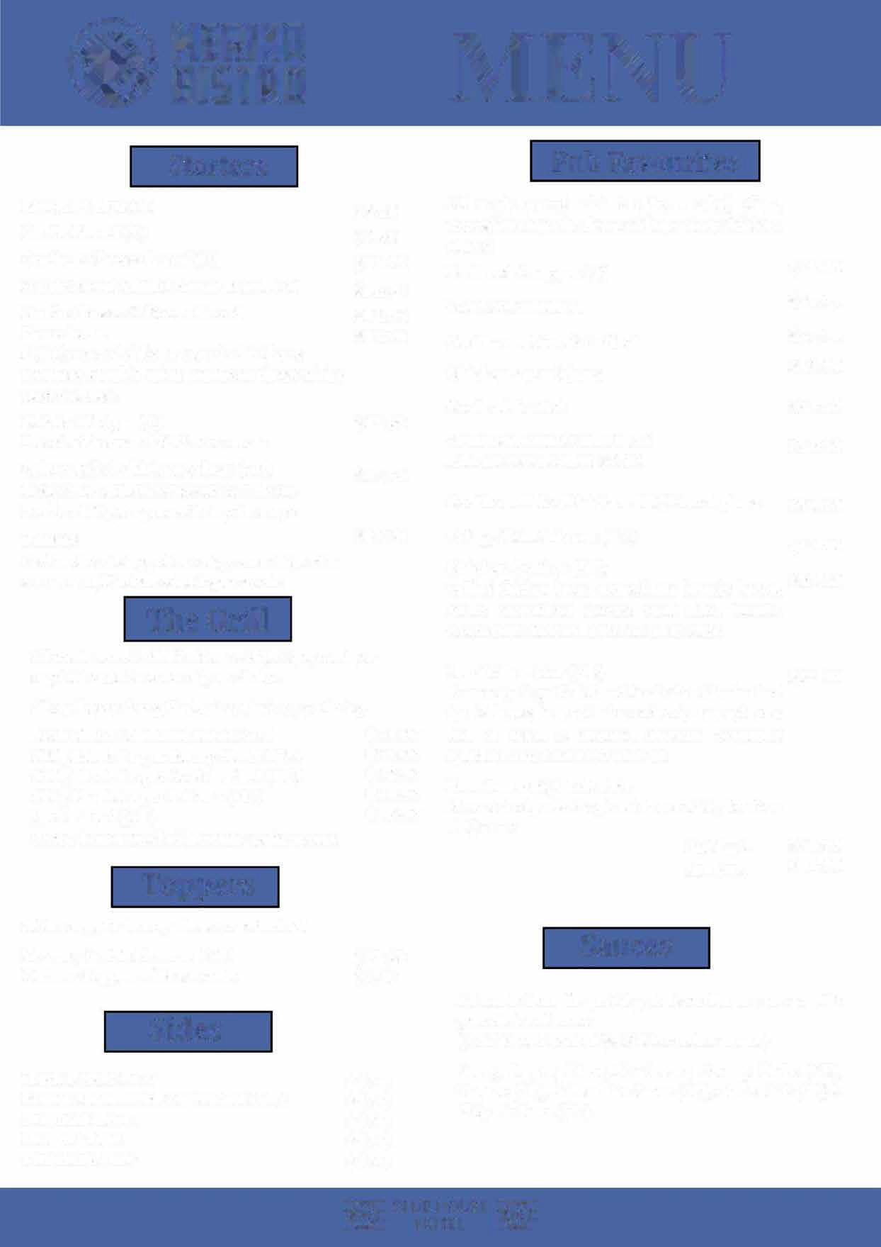
� CLUB HOUSE �
� HOT L L �


Burgers Salads

Veggie Burger (V)
Two potato rosti with cos lettuce, tomato, cheese, aioli & chips
Southern Fried Chicken Burger
Freshly dusted Southern fried chicken, American cheddar cheese, cos lettuce, tomato, tangy slaw, chipotle aioli & chips
Steak Burger
Scotch fillet, American cheddar cheese, cos lettuce, tomato, carmalised onion, slaw, BBQ sauce, aioli & chips
Doggie's Double Beef Burger
House minced beef patties, American cheddar cheese, tomato, cos lettuce, burger sauce, onion rings &chips
$24.90

$24.90

$24.90

$24.90
Caesar Salad
Cos lettuce, garlic croutons, bacon, parmesan cheese with creamy caesar dressing topped with an egg
Chicken Caesar Salad
Grilled chicken breast, cos lettuce, garlic croutons, bacon, parmesan cheese with creamy caesar dressing topped with an egg
Thai Beef Salad
Marinated beef strips grilled and served on a Thai garden salad

Pasta
$18.90

$24.90

$26.90

Kid's Meals
All kids' meals are served with chips, tomato sauce & ice-cream.
Carbonara Chicken Carbonara
Chicken breast, onion, garlic, bacon, & mushroom tossed in a creamy sauce, served with fettuccine & topped with parmesan cheese
Bolognese
$20.00

$24.00

Chicken Schnitzel Chicken Nuggets Battered Fish
Mini Bacon & Cheese Pizza Beef & Cheese Burger
Additional Kid's Pack
$12.50
$12.50
$12.50
$12.50
$15.50

$4.00
Home style bolognese fettuccine topped with parmesan cheese
Chilli Prawn Pasta (Mild or Hot)
Creamy napoli, garlic, onion, chilli & prawns tossed through fettuccine & sprinkled with parmesan cheese
$24.00

$29.90

Desserts

Please see the Specials Board for Chet"s selection of delicious desserts.
Our menu may contain or come into contact with wheat, eggs, peanuts, tree nuts and milk. Due to this we are unable to 100% guarantee that our menu items can be completely free of allergens. If you have any dietary requirements or allergens please ask to speak with the Chef who will be happy to work with you.

GF - Gluten Free V - Vegetarian

www.clubhousehotelyass.com.au 0 Follow us on Facebook & lnstagram

